**WorkSheet:- 2.4**

**Student Name:** Vivek Kumar **UID:** 21BCS8129

**Branch:** BE-CSE (LEET) **Section/Group:** 20BCS-809/A

**Semester:** 4th Sem **Date of Performance:** 19/04/2022

**Subject Name:** SE Lab **Subject Code:** 20CSP-255

**AIM: -** Design a class diagram for following scenario Online shopping domain model

**Purpose:** Show some domain model for online shopping - Customer, Account, Shopping Cart, Product, Order, Payment.

**Summary:** Example of a UML class diagram representing online shopping domain. Each customer could have some web user identity. Web user could be in one of several states and could be linked to a shopping cart.

**Solution: -** Class diagram is a static diagram. It represents the static view of an application. Class diagram is not only used for visualizing, describing, and documenting different aspects of a system but also for constructing executable code of the software application.

**Purpose:**  The purpose of class diagram is to model the static view of an application. Class diagrams are the only diagrams which can be directly mapped with object-oriented languages and thus widely used at the time of construction.

The purpose of the class diagram can be summarized as –

* Analysis and design of the static view of an application.
* Describe responsibilities of a system.
* Base for component and deployment diagrams.
* Forward and reverse engineering.

**Online shopping domain** **Model:**

Here we provide an example of UML class diagram which shows a domain model for online shopping. The purpose of the diagram is to introduce some common terms, "dictionary" for online shopping - Customer, Web User, Account, Shopping Cart, Product, Order, Payment, etc. and relationships between. It could be used as a common ground between business analysts and software developers.

Each customer has unique id and is linked to exactly one account. Account owns shopping cart and orders. Customer could register as a web user to be able to buy items online. Customer is not required to be a web user because purchases could also be made by phone or by ordering from catalogues. Web user has login name which also serves as unique id. Web user could be in several states - new, active, temporary blocked, or banned, and be linked to a shopping cart. Shopping cart belongs to account.

Account owns customer orders. Customer may have no orders. Customer orders are sorted and unique. Each order could refer to several payments, possibly none. Every payment has unique id and is related to exactly one account.

Each order has current order status. Both order and shopping cart have line items linked to a specific product. Each line item is related to exactly one product. A product could be associated to many line items or no item at all.

**Class Diagram:**

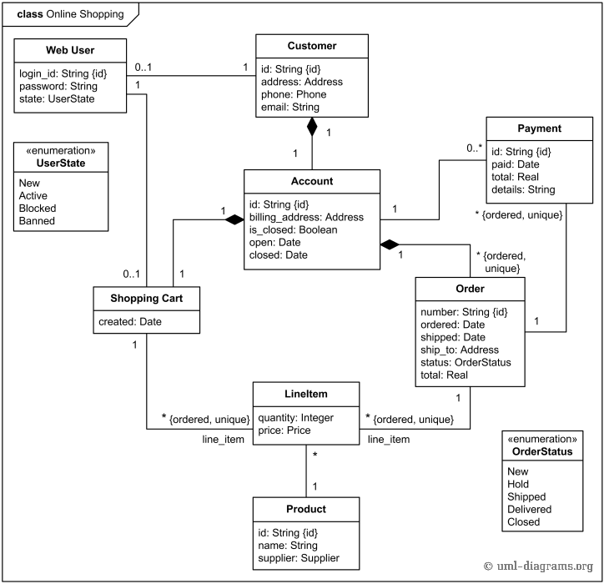

**Evaluation Grid (To be created as per the SOP and Assessment guidelines by the faculty):**

|  |  |  |  |
| --- | --- | --- | --- |
| Sr. No. | Parameters | Marks Obtained | Maximum Marks |
| 1. |  |  |  |
| 2. |  |  |  |
| 3. |  |  |  |
| 4. |  |  |  |